Practice Problems Section 17 Solutions

1. 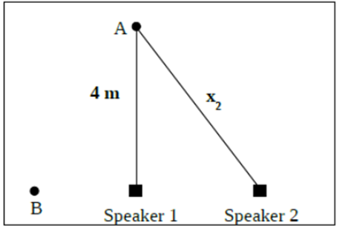Two speakers are producing sound waves with an identical frequency of 172 Hz. Assume the speed of sound is 344 m/s.
2. At location A the sound intensity is zero. What is the minimum possible distance from speaker 2 to location A? **Show your work!** (*Note: the distance from the speakers to your location is not much greater than the distance between the speakers*)

To get zero intensity, we must have destructive interference. Thus, the minimum possible distance from speaker 2 to point A will occur when the path length difference is one-half of a wavelength. First, we find the wavelength,

$$λ=\frac{v}{f}=\frac{344}{172}=2.00\text{ m}$$

Then we impose

$$r_{2}-r_{1}=\frac{λ}{2}→x_{2}-4=1→x_{2}=5.00 \text{m}$$

1. Now you go stand at position B, which is directly to the left of speakers 1 and 2, as shown. Will the sound intensity be a maximum, zero, or something in between? **Show your work!**

Now, we need to determine whether the path length difference at point B is a whole number of wavelengths, a half-number of wavelengths, or something else. To do this, we note that the distance between speakers 1 and 2 (using the Pythagorean theorem) is 3.00 m. Thus,

$$r_{2B}-r_{1B}=3.00\text{ m}$$

Next, we note that 3.00 m is (3/2)*2.00 m and thus,

$$r_{2B}-r_{1B}=\frac{3}{2}λ$$

Therefore, since the path length difference to point B is a half-number of wavelengths, we have destructive interference at that location.

**Thus, there will be zero intensity at location B.**

1. In a double-slit experiment, the slit spacing is 0.300 mm. A screen is placed 4.00 m away and you observe an interference pattern on the screen. The distance on the screen from the central maximum to the second dark spot above the central maximum is measured to be 1.50 cm. What wavelength of light (in nm) was used? **Show your work!**

The second dark spot above the central maximum occurs when the path length difference is $\frac{3}{2}λ$

(i.e. the $m=1$ destructive interference location). Since the distance to the observation point is much further than the distance between the slits, we can use the far-field approximation, $Δr≈d\sin{θ}$. Thus,

$$d\sin{θ}=\frac{3}{2}λ$$

To find $θ$, we need to draw a picture of the situation.

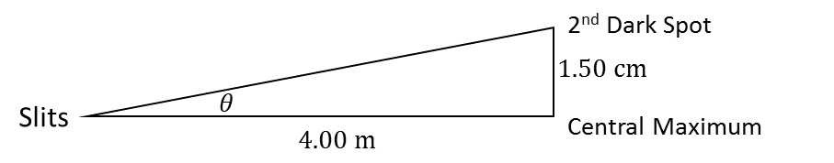

Thus,

$$θ=\tan^{-1}\left(\frac{.0150 \text{m}}{4.00 \text{m}}\right)=.215°$$

Thus,

$$\left(3.00×{10}^{-4} \text{m}\right)\sin\left(.215°\right)=\frac{3}{2}λ→λ=7.50×{10}^{-7} \text{m}$$

Thus,

$$λ=750 \text{nm}$$

$\text{Constructive: }∆r=mλ$ $\text{Destructive: }∆r=\left(m+1/2\right)λ$

$∆r≈d\sin{θ}$ when $d≪\text{ distance to sources}$ $c=3.00×{10}^{8}$ m/s